MyDXC Onboarding Profile Setup Guide

Internal User guide

Release v1.0

|  |  |
| --- | --- |
| Document Name: | DXC Sofia MyDXC Onboarding Profile Setup Guide |
| Prepared By: | Dilyana Velinova |
| Preparation Date: |  |
| Document Owner: |  |
| Reviewed By: |  |
| Review Date: |  |
| Document location: |  |
|  | |

**Revision History**

| Ver. No. | Ver. Date | Revised By | Description – What is Changed (Added or Modified) |
| --- | --- | --- | --- |
|  |  |  |  |
|  |  |  |  |

**Purpose and scope of the document**

* This document represents a self-help guide
* The purpose of this document is to outline in simple steps the information that needs to be filled in every employee’s personal MyDXC Onboarding Profile.

# Go to [www.my.dxc.com](http://www.my.dxc.com)

# Type ‘onboarding’ in the search box and hit Enter

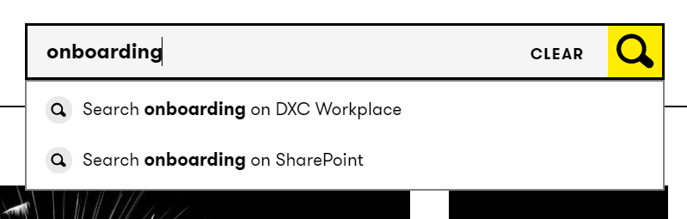

# Click DXC Onboarding

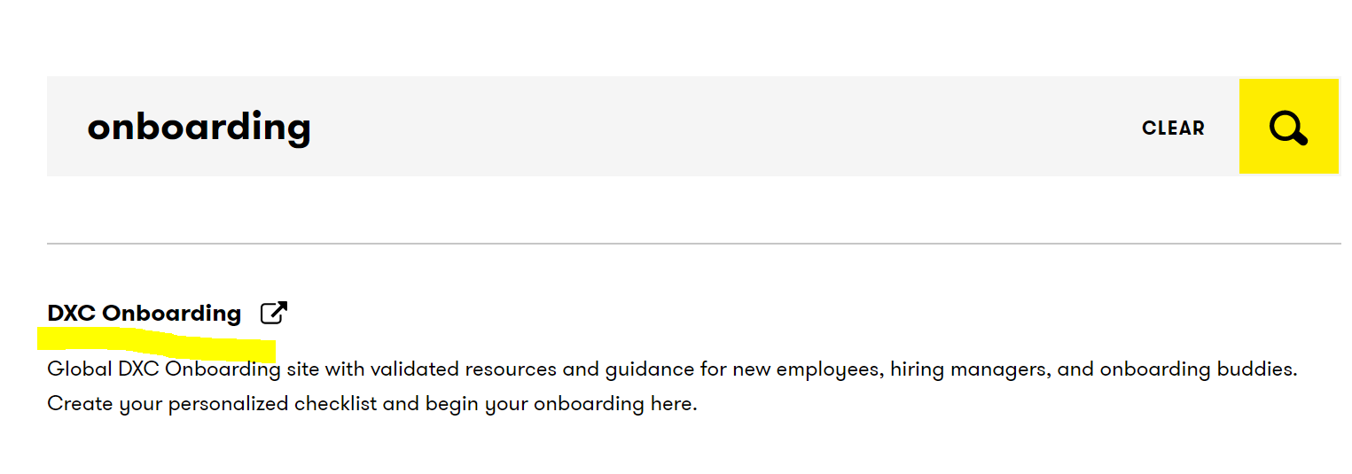

# Click Begin Onboarding

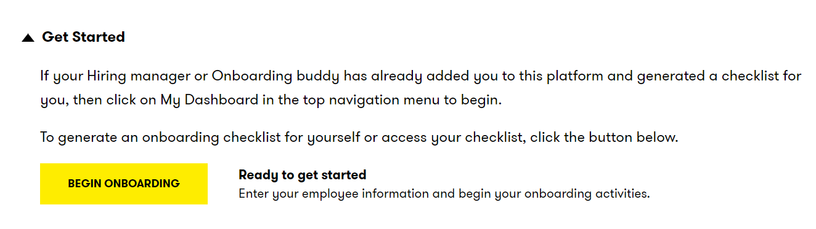

# Fill in the form with the information provided below

**New employee:** your DXC email

**Hiring manager:** your hiring manager **\***

**Onboarding buddy:** Dimitar Nedev **

**Hire type:** University graduate (for all new graduates) OR Experienced employee

**Start date:** your start date

**Business or global function:** Services

**Business or global function subgroup:** Deliver

**Region:** North and Central Europe

**Military affiliated employee:** No

**Transitioned employee:** Yes OR No

**Acquisition employee:** No

*NOTE: You can check who your hiring manager is by visiting <https://www.myworkday.com/csc/d/home.htmld>

Click on the profile icon in the top right corner 🡪 Click ‘View Profile’ 🡪 See your manager in the dashboard

**NOTE: The Onboarding buddy and Hiring manager fields cannot contain the same person. If Dimitar Nedev is also your Hiring manager, leave the Onboarding buddy field empty.

# Click ‘Next’

# Review your information and hit ‘Submit’